IMPORTANT!

This project ran using a database that has since been deleted, and thus cannot run in its current state. Below are screenshots of the project being run so you can get a feel for how it worked.

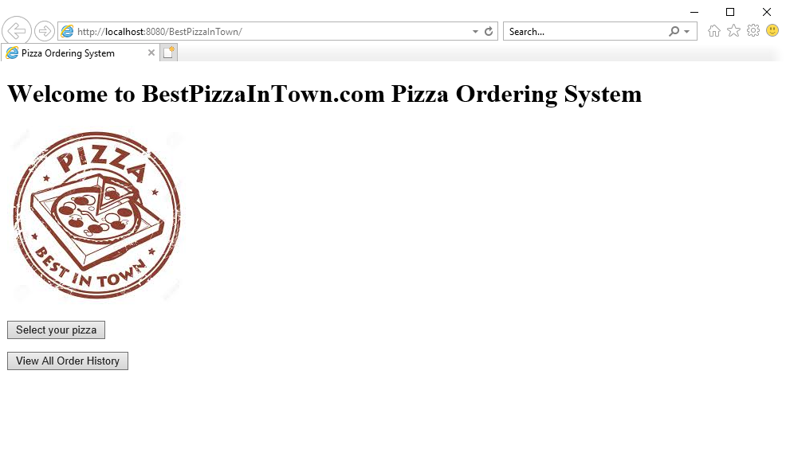

The main page

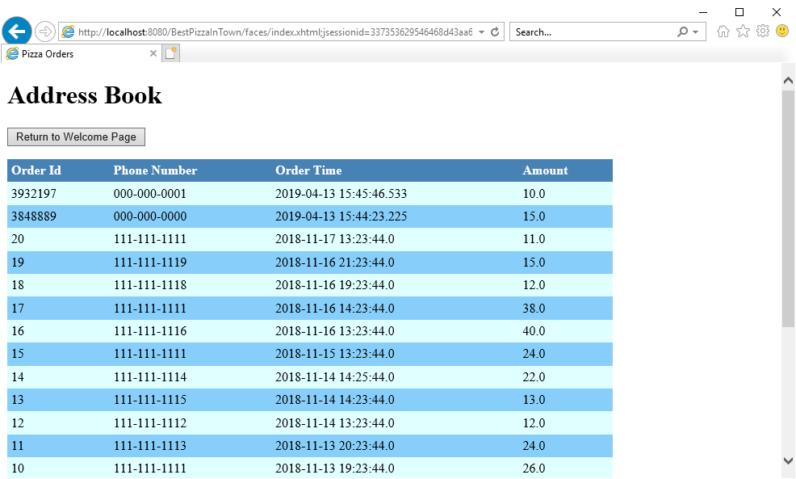

The “view all order history” page shows all the past orders made. The first 20 orders (ID# 1-20) are the ones that were already part of the database. All the other orders are test cases and a ~~random~~ timestamp integer was generated as an ID for each order.

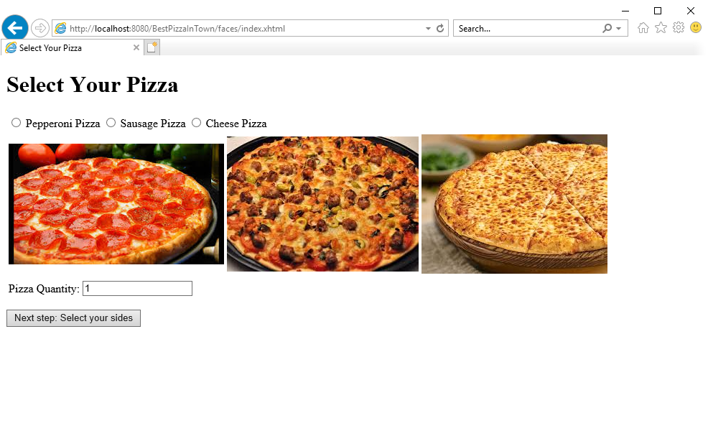

The “select your pizza” page allows the user to select a pizza they want and the amount of pizzas they want. The default order quantity is 1

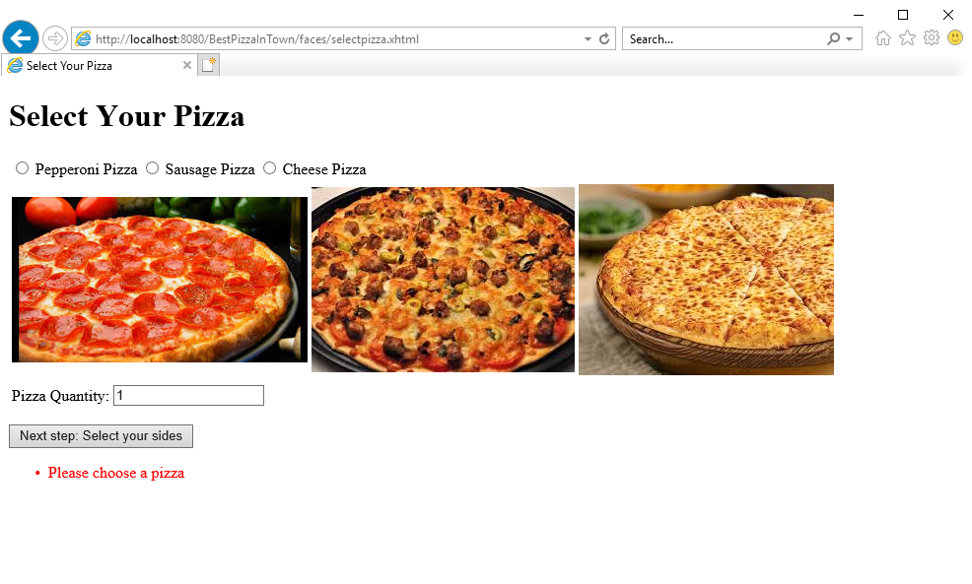

If the user doesn’t select a pizza, the webpage will not let the user progress and will prompt the user to pick what kind of pizza they want. The user can choose to take 0 pizzas if they don’t want any pizza

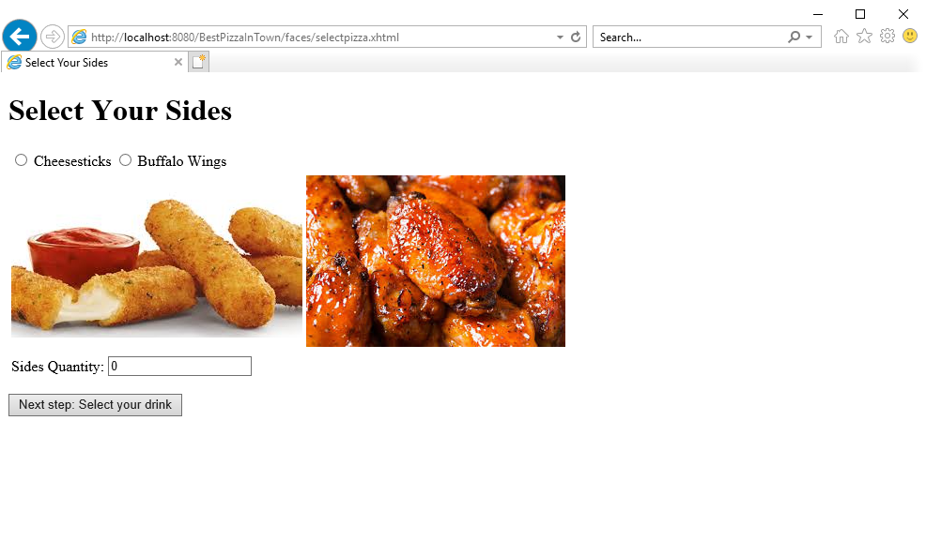this process repeats for sides and drinks, with default order quantity 0

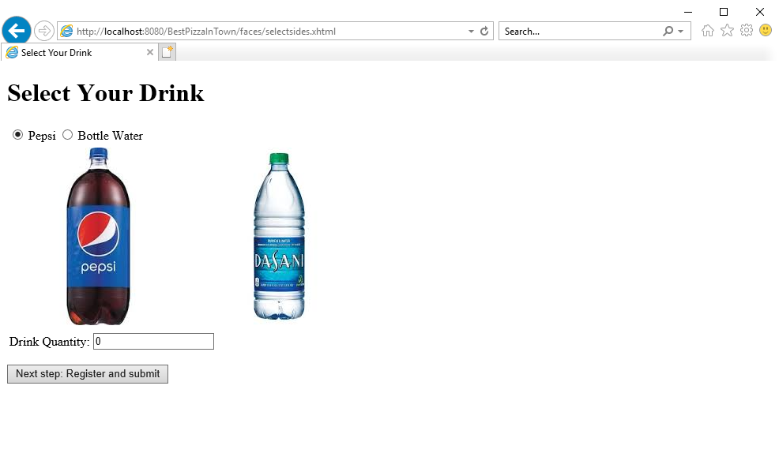

Afterwards, the user is prompted to enter their name and phone number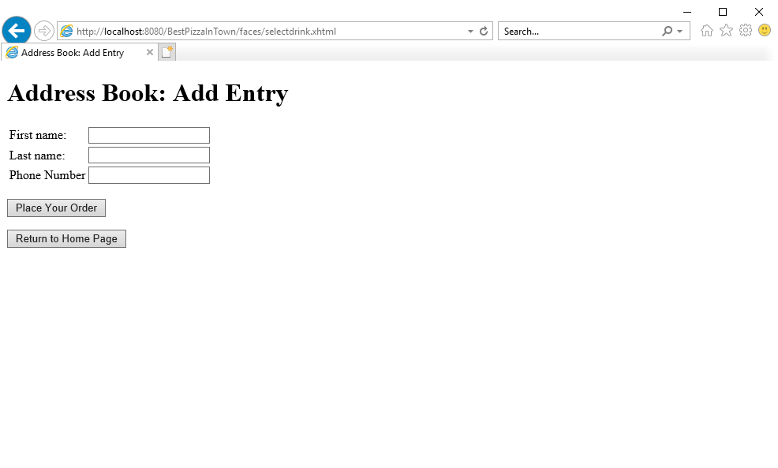

If the user leaves any of these fields blank or enters an invalid response, the user is not allowed to continue and is instead prompted to fill the text fields

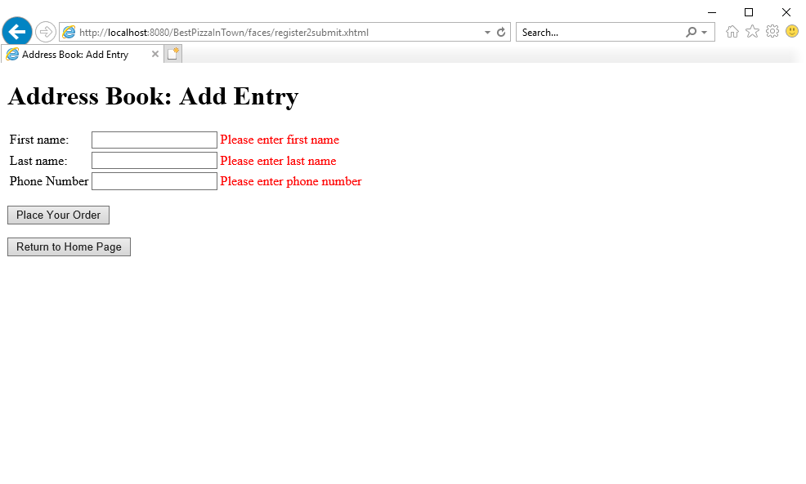

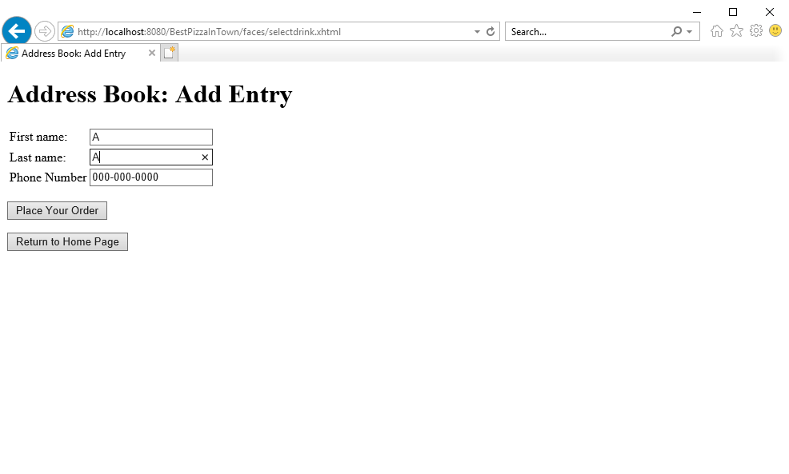After the user correctly fills the text fields, they can place the order or return to the home page

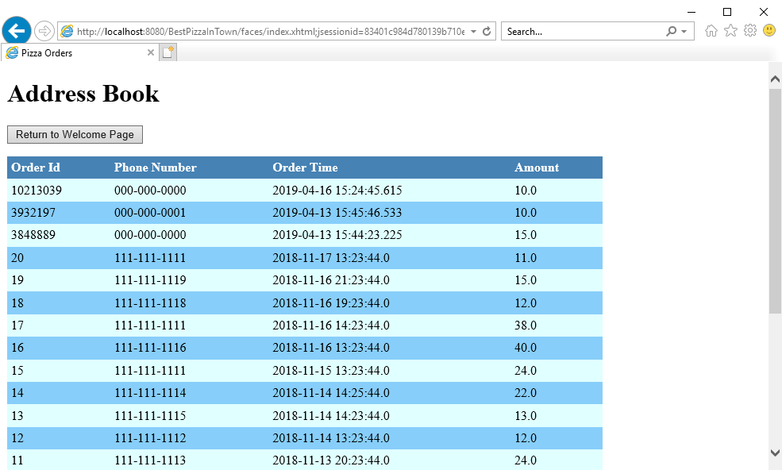If the user places the order, the order will be added to the beginning of the database which can be viewed by clicking “view all order history” on the main page. If the user chooses to instead return to the home page, the order is not processed, and nothing is added to the database